Design Thinking Process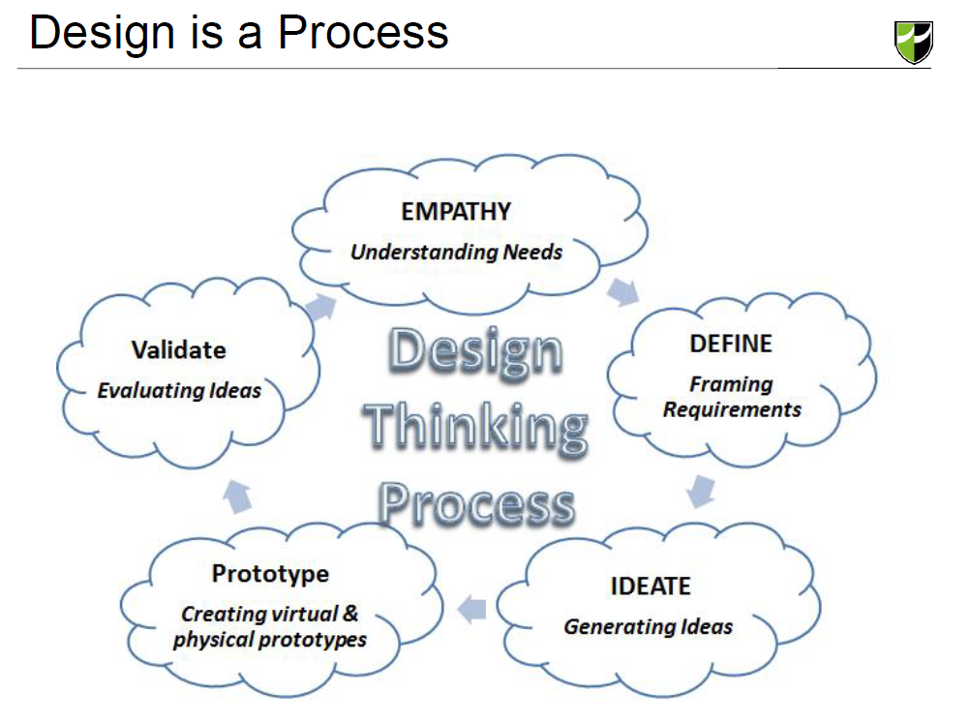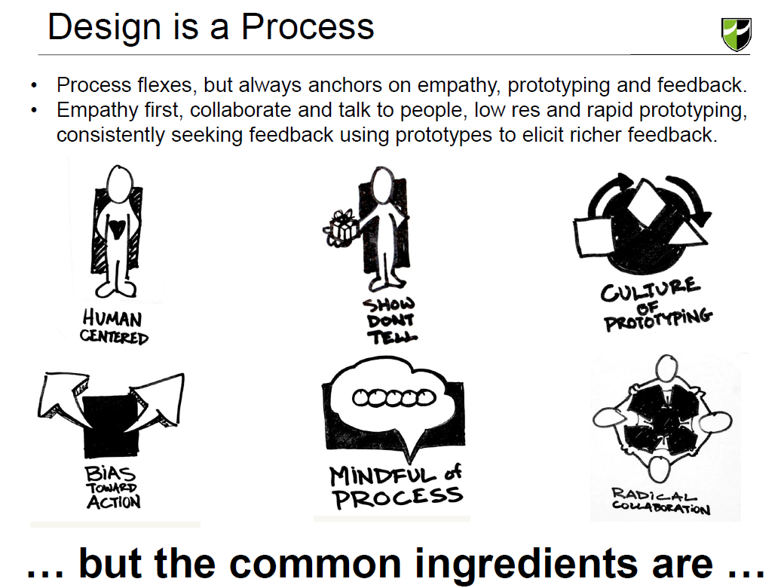

Design Thinking Process

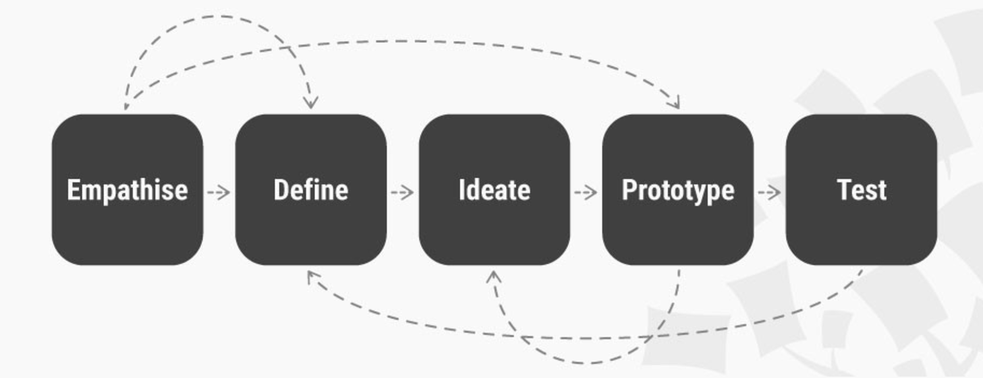

Design Thinking is a design methodology that provides a solution-based approach to solving problems. It’s extremely useful in tackling complex problems that are ill-defined or unknown, by understanding the human needs involved, by re-framing the problem in human-centric ways, by creating many ideas in brainstorming sessions, and by adopting a hands-on approach in prototyping and testing. Understanding these five stages of Design Thinking will empower anyone to apply the Design Thinking methods to solve complex problems that occur around us — in our companies, our countries, and even our planet.

**1. Empathise**

The first stage of the Design Thinking process is to gain an empathic understanding of the problem you are trying to solve. This involves consulting experts to find out more about the area of concern through observing, engaging and empathizing with people to understand their experiences and motivations, as well as immersing yourself in the physical environment to have a deeper personal understanding of the issues involved. Empathy is crucial to a human-centred design process such as Design Thinking, and empathy allows design thinkers to set aside his or her own assumptions about the world to gain insight into users and their needs.

Depending on time constraints, a substantial amount of information is gathered at this stage to use during the next stage and to develop the best possible understanding of the users, their needs, and the problems that underlie the development of that product.

**2. Define (the Problem)**

During the Define stage, you put together the information you have created and gathered during the Empathise stage. You will analyse your observations and synthesise them to define the core problems that you and your team have identified up to this point. You should seek to define the problem as a problem statement in a human-centred manner.

For example, instead of defining the problem as your own wish or a need of the company we can illustrate it such as, “We need to increase our food-product market share among young teenage girls by 5%,” a much better way to define the problem would be, “Teenage girls need to eat nutritious food in order to thrive, be healthy and grow.”

The Define stage will help the designers in your team gather great ideas to establish features, functions, and any other elements that will allow them to solve the problems or, at the very least, allow users to resolve issues themselves with the minimum of difficulty. In the Define stage you will start to progress to the third stage, Ideate, by asking questions which can help you look for ideas for solutions by asking: “How might we… encourage teenage girls to perform an action that benefits them and involves your company’s food-product or service?”

**3. Ideate**

During the third stage of the Design Thinking process, designers are ready to start generating ideas. You’ve grown to understand your users and their needs in the Empathise stage, and you’ve analysed and synthesised your observations in the Define stage, and ended up with a human-centred problem statement. With this solid background, yourself and your team members can start to 'think outside the box' to identify new solutions to the problem statement you’ve created, and you can start to look for alternative ways of viewing the problem. There are hundreds of Ideation techniques such as Brainstorm, Brainwrite, Worst Possible Idea, and SCAMPER. Brainstorm and Worst Possible Idea sessions are typically used to stimulate free thinking and to expand the problem space. It is important to get as many ideas or problem solutions as possible at the beginning of the Ideation phase. You should pick some other Ideation techniques by the end of the Ideation phase to help you investigate and test your ideas to find the best way to either solve a problem, or provide the elements required to circumvent the problem.

**4. Prototype**

The design team will now produce a number of inexpensive, scaled down versions of the product or specific features found within the product, so they can investigate the problem solutions generated in the previous stage. Prototypes may be shared and tested within the team itself, in other departments, or on a small group of people outside the design team. This is an experimental phase, and the aim is to identify the best possible solution for each of the problems identified during the first three stages. The solutions are implemented within the prototypes and, one-by-one, they are investigated and either accepted, improved and re-examined, or rejected based on the users’ experiences. By the end of this stage, the design team will have a better idea of the constraints inherent within the product, the problems that are present, and have a better/more informed perspective of how real users would behave, think, and feel when interacting with the end product.

**5. Test**

Designers or evaluators rigorously test the complete product using the best solutions identified during the prototyping phase. This is the final stage of the 5 stage-model, but in an iterative process, the results generated during the testing phase are often used to redefine one or more problems and inform the *understanding* of the users, the conditions of use, how people think, behave, and feel, and to empathise. Even during this phase, alterations and refinements are made to rule out problem solutions and derive as deep an understanding of the product and its users as much as possible.

**The Non-Linear Nature of Design Thinking**

In practice, the process is carried out in a more flexible and non-linear fashion. For example, more than one stage may be conducted concurrently by different groups within the design team, or the designers may collect information and prototype during the entire project to enable them to bring their ideas to life and visualise the problem solutions. This includes results from the testing phase may reveal some insights about users, which in turn may lead to another brainstorming session (ideation) or the development of new prototypes.

It is important to note that the five stages are not always sequential — they do not have to follow any specific order and they can often occur in parallel and be repeated iteratively. As such, the stages should be understood as different modes that contribute to a project, rather than sequential steps. However, the amazing thing about the five-stage Design Thinking model is that it systematises and identifies the 5 stages/modes you would expect to carry out in a design project – and in any innovative problem-solving project. Every project will involve activities specific to the product under development, but the central idea behind each stage remains the same.

**The Take Away**

The Design Thinking process is iterative, flexible and focused on collaboration between designers and users, with an emphasis on bringing ideas to life based on how real users think, feel and behave.

Design thinking tackles complex problem by:

1. Empathising: Understanding the human needs involved.
2. Defining: Re-framing and defining the problem in human-centric ways.
3. Ideating: Creating many ideas in ideation sessions.
4. Prototyping: Adopting a hands-on approach in prototyping.
5. Testing: Developing a prototype/solution to the problem.

**Advantages of this process:**

1. Gives you the opportunity to view a problem from a different perspective.
2. Allows you to delve into a problem to determine its root cause.
3. Encourages innovative thinking and creative problem solving.
4. Ensures that the outcome meets objectives and client requirements.
5. Results in an experience that is more effective and informative for your learners.

**Design vs Design Thinking**

The design is not all about looks. People are restricted to this façade of appearance and blinded with the illusion of visual appeal. Unfortunately, that is not all. The design is about crafting something new and shelling out a form through expertise so as to provide interactive solutions for complex situations. As a matter of fact, look around, you will find everything designed. And did you know that design ability is also one of the three basics dimensions of human intelligence? Yes, our cognitive ability comprises of science, art, and DESIGN.

So, it is best if we break free from the silo mentality we follow in organizations and start inculcating a cross-disciplinary outlook to encourage innovation. Design thinking brings forth a systematic framework for implementing innovation that fosters organic growth and serves real value to the clients. Creativity is the focal point in any design process. The design thinking stages include observation to learn about the left out needs in relation to the context and constraints of a typical situation, discovering the opportunity and the capacity of innovation, forming brilliant ideas, testing and improving.

**The Power**

Thinking in design empowers the designers to create the right features for the right people. It defines the user experience clearly as a whole not merely in terms of interaction and visual design. It ensures that designers deal with real user problems and thus avoid creating something that is undesirable. Design thinking gives the edge to pass the right decisions when it comes to forming features.

The concept allows the designers to pose right questions, create right features and engage with the clients effectively.

Arduino

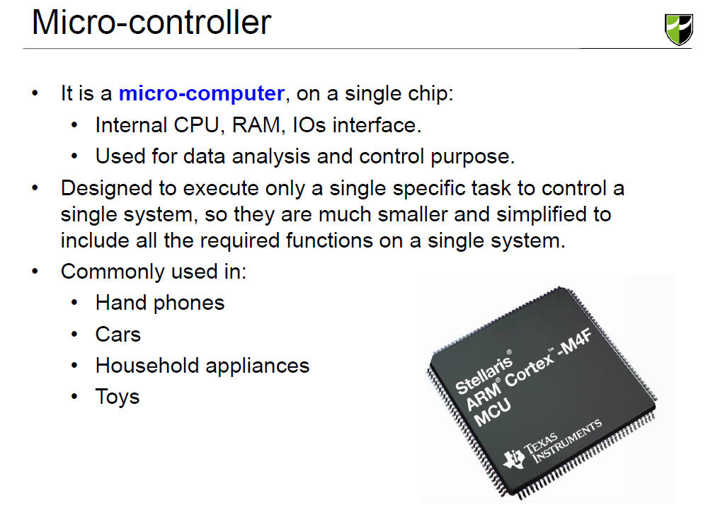

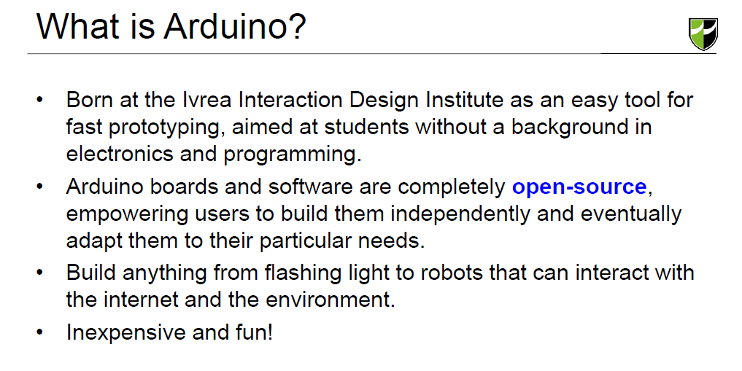

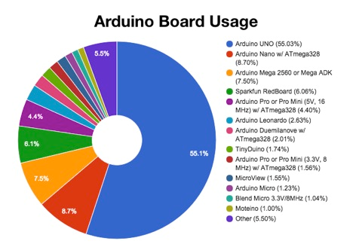

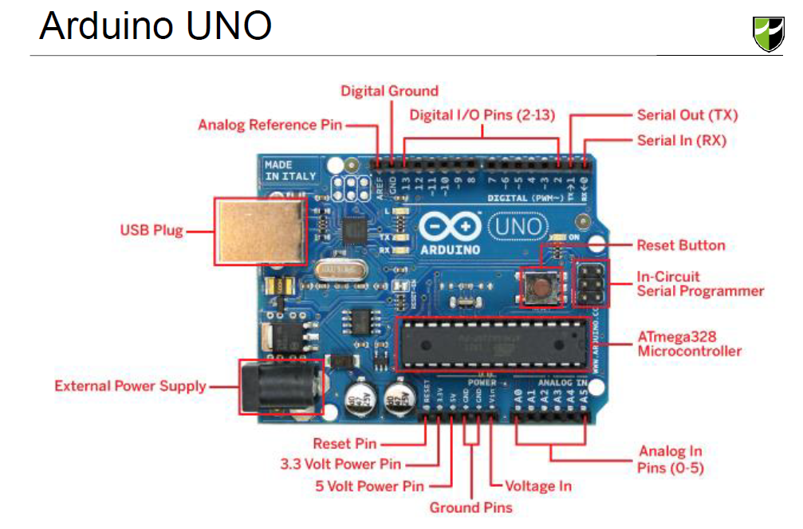

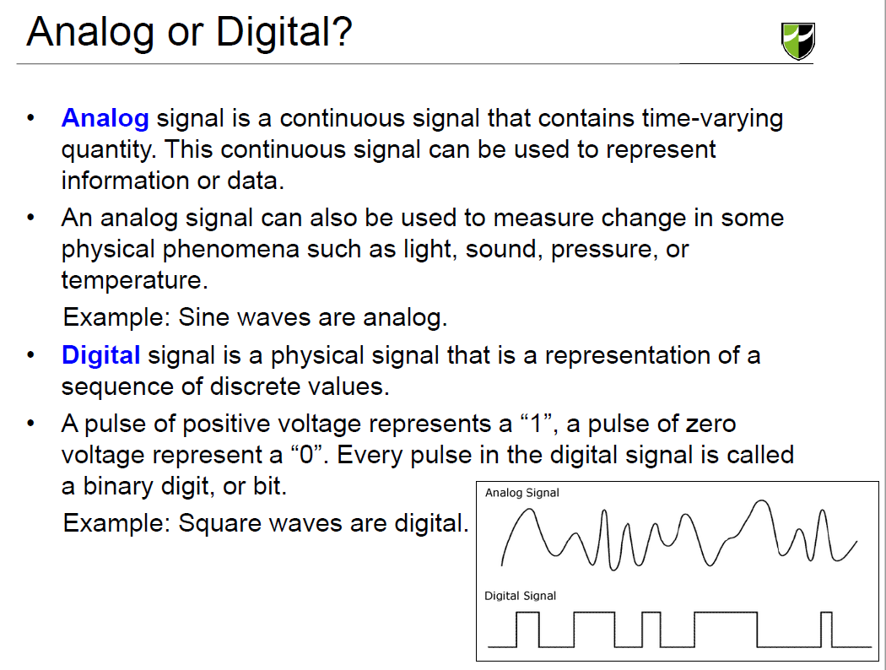

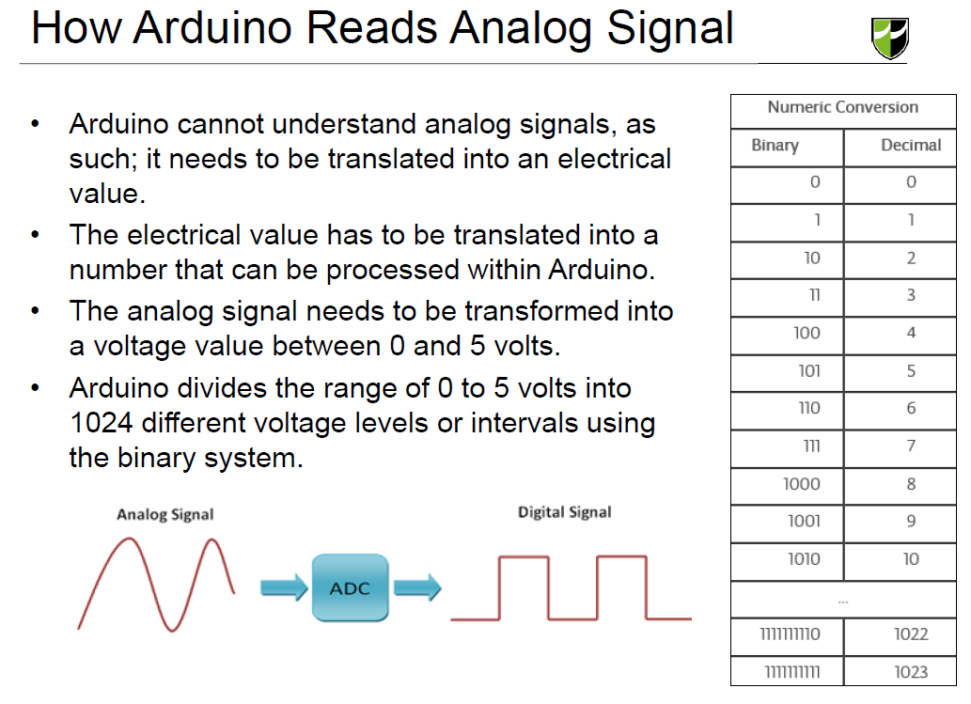

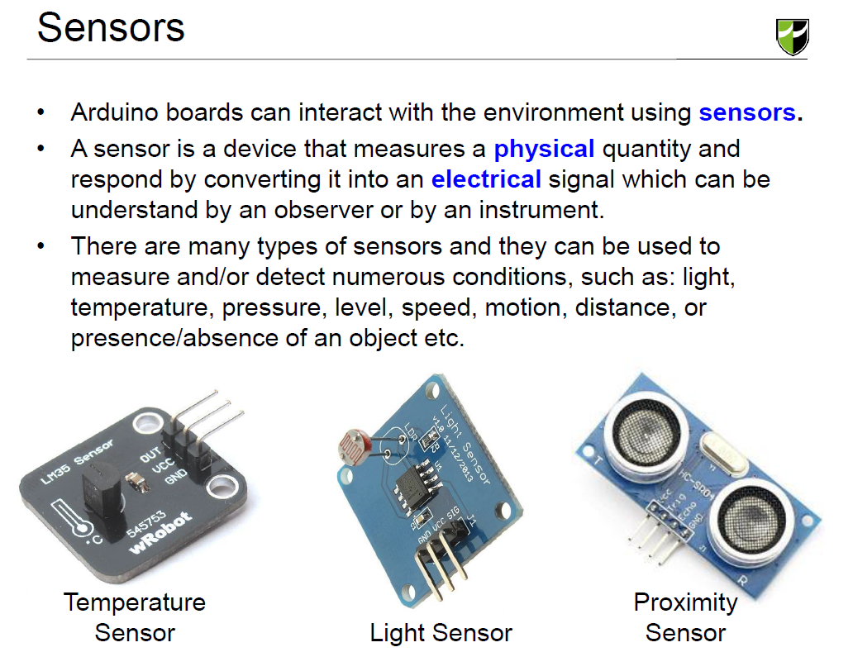

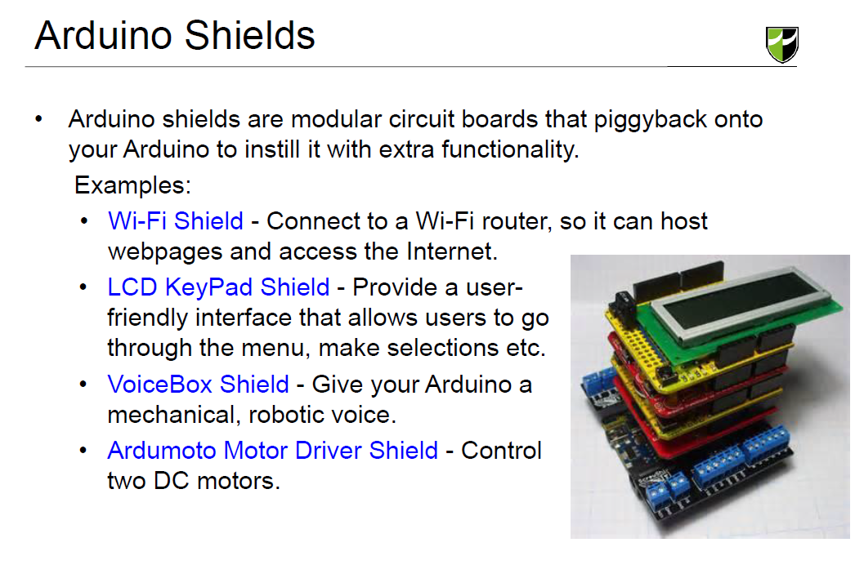

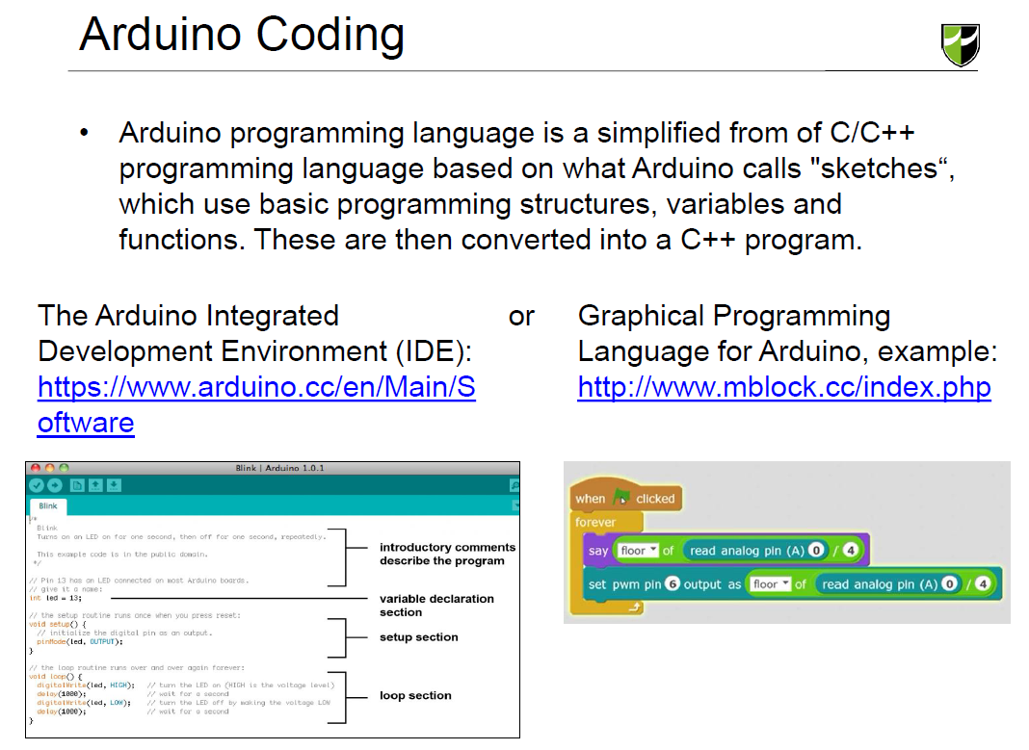

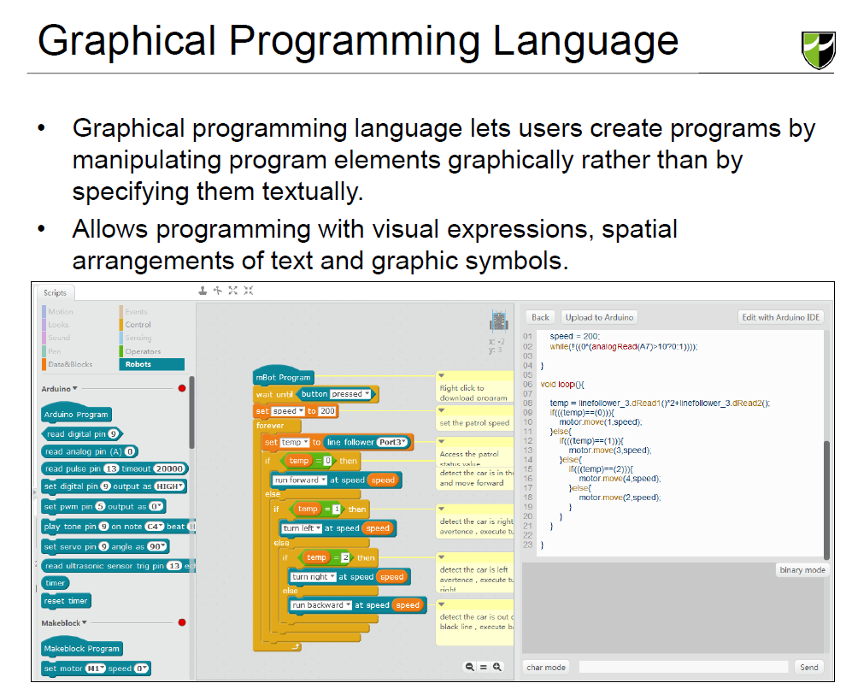

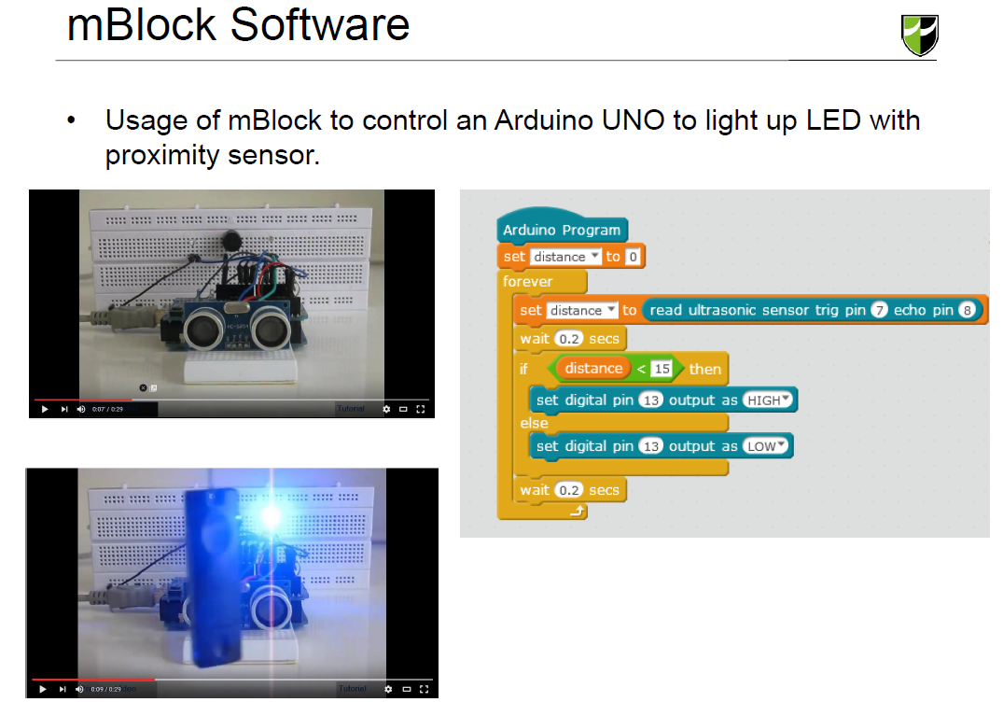

**Micro-Controller**

A microcontroller is a self-contained system with peripherals, memory and a processor that can be used as an embedded system. Most programmable microcontrollers that are used today are embedded in other consumer products or machinery including phones, peripherals, automobiles and household appliances for computer systems. Due to that, another name for a microcontroller is "embedded controller." Some embedded systems are more sophisticated, while others have minimal requirements for memory and programming length and a low software complexity. Input and output devices include solenoids, LCD displays, relays, switches and sensors for data like humidity, temperature or light level, amongst others.

**Powering the Arduino**

Arduino/Genuino Uno is a microcontroller board based on the ATmega328P (datasheet). It has 14 digital input/output pins (of which 6 can be used as PWM outputs), 6 analog inputs, a 16 MHz quartz crystal, a USB connection, a power jack, an ICSP header and a reset button. It contains everything needed to support the microcontroller; simply connect it to a computer with a USB cable or power it with a AC-to-DC adapter or battery to get started.

**Analog and Digital Inputs/Outputs**

An analog signal is one that can take on any number of values, unlike a digital signal which has only two values: HIGH and LOW. To measure the value of analog signals, the Arduino has a built-in analog-to-digital converter (ADC). The ADC turns the analog voltage into a digital value. The function that you use to obtain the value of an analog signal is analogRead(pin). This function converts the value of the voltage on an analog input pin and returns a digital value from 0 to 1023, relative to the reference value. The reference is 5V on most Arduinos, 7V on the Arduino Mini and Nano, and 15V on Arduino Mega. It has one parameter which is the pin number.

The Arduino does not have a built-in digital-to-analog converter (DAC), but it can pulse-width modulate (PWM) a digital signal to achieve some of the functions of an analog output. The function used to output a PWM signal is Analog Write(pin, value). Pin is the pin number used for the PWM output. Value is a number proportional to the duty cycle of the signal. When value = 0, the signal is always off. When value = 255, the signal is always on. On most Arduino boards, the PWM function is available on pins 3, 5, 6, 9, 10, and 11. The frequency of the PWM signal on most pins is approximately 490 Hz. On the Uno and similar boards, pins 5 and 6 have a frequency of approximately 980 Hz. Pins 3 and 11 on the Leonardo also run at 980 Hz.

To map an analog input value, which ranges from 0 to 1023 to a PWM output signal, which ranges from 0 - 255, you can use the map(value, fromLow, fromHigh, toLow, toHigh) function. This function has five parameters, one is the variable in which the analog value is stored, while the others are 0, 1023, 0 and 255 respectively.

**Arduino Shields**

Shield Form Factor

Every Arduino shield must have the same form-factor as the standard Arduino. Power and ground pins on one eight (previously six) pin header, and analog pins on a six-pin header next to that. Digital pins cover the other edge on the other side, an eight-pin header separated from a 10-pin by that weird 0.5" spacing. Some shields also require a connection to the Arduino’s ICSP header (the 2x3 programming header on the end).

Prototyping shields

1. ProtoScrew Shield - Like the ProtoShield, but each pin is also broken out to a screw terminal. Handy for connecting to external motors or heavy-duty sensors.
2. Go-Between Shield - The intention of this shield is to sit in between two shields. It swaps the pins of the top shield, so they don’t interfere with each other.
3. LiPower Shield - This shield allows you to power your Arduino with a Lithium Polymer battery.
4. Danger Shield - The most awesomest shield evar! This shield is a crazy conglomeration of displays, potentiometers, and other sensors. Great for learning the ins and outs of Arduino or incorporating into audio mixing projects.
5. Joystick Shield Kit - This makes your Arduino a bare-bones controller. With a joystick and four buttons, this makes for a great robot controller.
6. microSD Shield - The Arduino has limited storage space, but this easy-to-use shield (along with the SD library) allow for plenty of extra storage.

Music and Sound

1. MP3 Player Shield - Turn your Arduino into an MP3 player. Just plug in a µSD card, add some speakers, upload the example code, and you can make your very own MP3 Playing Music Box
2. Music Instrument Shield - Use the MIDI protocol to turn your Arduino into a bank of musical instruments. It can make drums, piano, woodwinds, brass, and all sorts of other sound effects.
3. Spectrum Shield - The Spectrum Shield listens to audio, and sorts it into bins of different frequencies. Use it to make a nifty graphic equalizer display.
4. VoiceBox Shield - Give your Arduino a mechanical, robotic voice.

Ethernet, WiFi, Wireless, GPS, Etc.

1. Arduino Ethernet Shield - This is one of the more classic shields. The Ethernet Shield supplies your Arduino with an ability to connect to the world wide web. There’s a great library to support it as well.
2. WiFly Shield - SparkFun’s WiFi Shield mainstay, this shield equips your Arduino with the ability to connect to 802.11b/g wireless networks. Then it can act as either a web server, client, or both.
3. Arduino Wi-Fi Shield - This is the Arduino Ethernet Shield sans wires. This shield can get your Arduino connected to a WiFi router, so it can host webpages and scour the Internet.
4. Electric Imp Shield - Electric Imp is a unique WiFi module, which looks like an SD card, but it packs a powerful cloud-based WiFi controller. This is probably the least expensive WiFi-enabling Arduino shield.
5. XBee Shield - XBee’s won’t get you connected to the Internet, but they do provide a solid, cheap means for communicating wirelessly. You could use an XBee to wirelessly trigger coffee machines, sprinklers, lights, or other household appliances.
6. Cellular Shield w/ SM5100B - Turn your Arduino into a cellular phone! Send SMS text messages, or hook up a microphone and speaker and use it to replace your iPhone.
7. GPS Shield - GPS isn’t as complicated as you might think. With a GPS Shield, your Arduino will always know where it is.

Displays and Cameras

1. Color LCD Shield - Equip your Arduino with a unique 128x128 cellular phone color LCD.
2. EL Escudo - Electroluminescent wire is awesome! Use this shield to add up to eight strands of EL wire to your project. You can finally make that Arduino-powered Tron costume.
3. CMUcam - This camera module adds vision to your Arduino. You can use it to track blobs, so your robot doesn’t hit any traffic cones.

Motor Drivers

1. Ardumoto Motor Driver Shield - This classic motor driver shield can control two DC motors.
2. Monster Moto Shield - If you need to drive beefier motors than the Ardumoto Shield can handle, this is the next step up.
3. PWM Shield - Usually when you think pulse-width modulation (PWM), you might think “dimming LEDs”, but PWM is also used to drive servo motors. This shield can be used to drive your crazy 12-servo hexapod.

Arduino Coding

To program the Arduino we need special software that will let us connect to the Arduino so we can code it. IDE stands for Integrated Development Environment. Let's break down that down:

Development stands for software development or coding. We use code to create programs.

Environment is exactly what it means, humans exist in a environment that's made up of oxygen and water + lots of other stuff we need to live. In computer programming an environment includes all the things we need to code our Arduino in it's little Arduino world.

Integrated. It just means that everything you need to code is all one place.

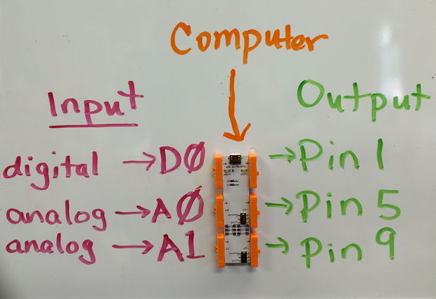

We can see that our module has a set of inputs one side and a set of outputs on the other. And the USB port let's us program the Arduino from our computer.

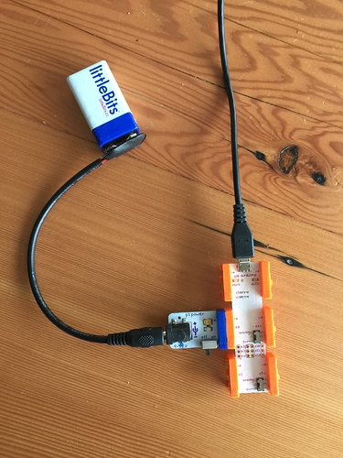

All we have to do now is grab our p1 power bit (blue), our Arduino (orange) and a USB cable. Make sure you've turned on your power bit and plugged in your USB cable.

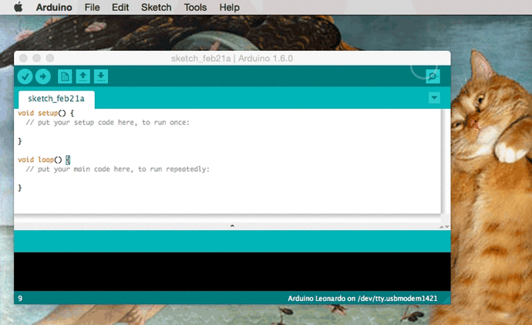

We need to tell the IDE what Arduino we're using and how we're communicating with it. So that means selecting our board which is based off of the Arduino Leonardo. Then we select port (our communication method) we'll be send our code through. Which is “tty.usbmodem…” for Mac, “cu.usbmodem…” for Windows.

Flipping the programming switch

Now we need to check everything is order we press the ❤and hopefully you'll see some lights blink on your Arduino and we'll have our very first program flashed!

The Arduino is equipped with a tiny bit of memory that allows it to save our program so when we unplug the device and turn it back on it will run program that was last uploaded.

If things go wrong don't fear, let's do a little troubleshooting:

- Make sure that your Arduino is powered on before you open your IDE.

- Try restarting the Arduino software.

- Try restarting your computer.

- Unplug your Arduino and plug it back in.

- Make sure the right port and board are selected.

Firstly you'll notice that the words **void** and ** setup**

void setup()

as well as **void** and **loop**.

void loop()

Are both **highlighted**. This is called **syntax highlighting**, it means those words are special **keywords** that give the Arduino a specific command. **void setup()** is a **function**.

a **function** is a lot like a **blender** it takes in some ingredients and gives us something delicious like so:

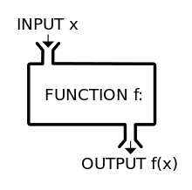

In addition to the name of the function we need to tell the Arduino what kind or **type** of function we want, in this case we'll be using **void**. We won't dive deeply into **types**. of functions (yet!) but just know that they come before **setup()** and **loop()** right now.

What's in a name?

Now that we have the **type** of function, we need to code the rest of it. Let's take a look at **setup**. Just like it's name implies it helps us **setup** our program.

And just like we need a mouth to speak, the code to **setup** our program will allow our Arduino to speak.

void setup() { }

The section after the parentheses **()** and in between the curly braces **{ }** is where we will write our first line of code that will enable the Arduino to talk to us.

it's called **Serial.begin()**.

void setup() {

Serial.begin(9600);

}

**Serial** is a command that defines how we'll be communicating to our computer.

**.begin(9600)** tells the Arduino to start the communication. You'll notice that there is a **dot** that separate's Serial and begin that is yet another syntax rule. Don't worry you'll remember all of this as you keep coding!

The **9600** tells the Arduino how fast it should talk to us. For most of the most part **9600** for what we're going to be doing.

NOTE: Right after our **function name** we have two **parentheses**every function has them just like you have a **type** and a **name**. Think of it as a **punctuation** mark. More on that in a bit.

Our second command is the **loop()** just like it implies it runs code over and over again. Just like like our circulatory system is a loop, the code inside of the **loop** is pumped through our program. In this case we're pumping code through the Arduino's veins. **Serial.println("hello littleWorld!");** is the command that we us to tell the Arduino to **speak**. Inside of the double quotes is where we put our message!

Let's fire it up!

Once you've typed up the sample code, hit the **upload** button found in the tool bar. It looks like this: and then open the **serial monitor** 

[[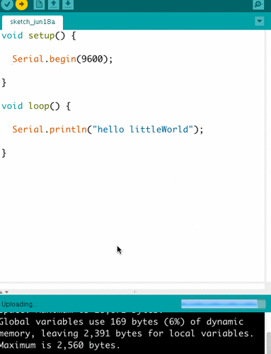](http://discuss.littlebits.cc/uploads/default/2162/a7b960cc0978e1f5.gif)](http://discuss.littlebits.cc/uploads/default/2162/a7b960cc0978e1f5.gif" \o "serialmonitor.gif)

In case you're seeing errors like this:

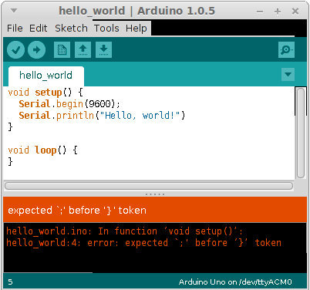

Or just can't upload:



Change your message!

Each time you make changes to your code don't forget to upload.

Why we do the things we do.

This code is an example of how you can communicate with your Arduino. And use that to talk to other programs on your computer like proccessing...etc.

**Advantages and Disadvantages of Arduino**

Advantages:

1- Ready to Use:

The biggest advantage of Arduino is its ready to use structure. As Arduino comes in a complete package form which includes the 5V regulator, a burner, an oscillator, a micro-controller, serial communication interface, LED and headers for the connections. You don't have to think about programmer connections for programming or any other interface. Just plug it into USB port of your computer and that's it. Your revolutionary idea is going to change the world after just few words of coding.

2- Examples of codes:

Another big advantage of Arduino is its library of examples present inside the software of Arduino. The process will start from learning the ADC's of micro-controller for measurement, went through the learning of serial communication for display and will end at USB - Serial converters. If you want to check this whole process click on the link below.

3- Effortless functions:

During coding of Arduino, you will notice some functions which make the life so easy. Another advantage of Arduino is its automatic unit conversion capability. You can say that during debugging you don't have to worry about the units conversions. Just use your all force on the main parts of your projects. You don't have to worry about side problems.

4- Large community:

There are many forums present on the internet in which people are talking about the Arduino. Engineers, hobbyists and professionals are making their projects through Arduino. You can easily find help about everything. Moreover the Arduino website itself explains each and every functions of Arduino.

Disadvantages:

1- Structure:

During building a project you have to make its size as small as possible. But with the big structures ofArduino we have to stick with big sized PCB’s. If you are working on a small micro-controller like ATmega8 you can easily make your PCB as small as possible.

2- Cost:

The most important factor which you cannot deny is cost. This is the problem which every hobbyist, Engineer or Professional has to face.

**Orthographical Projection**

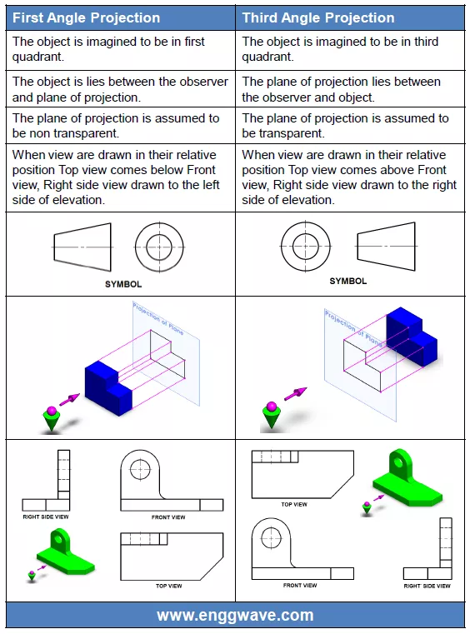

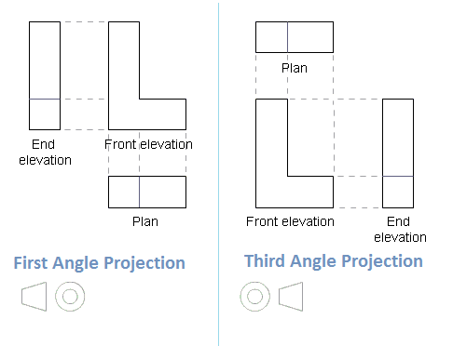

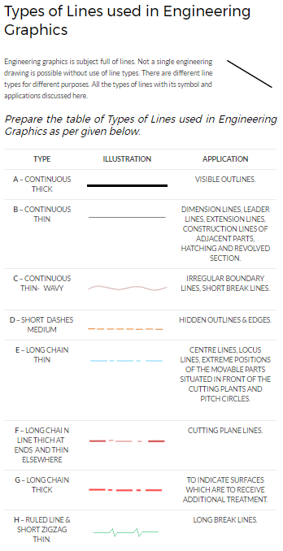

Business Strategy

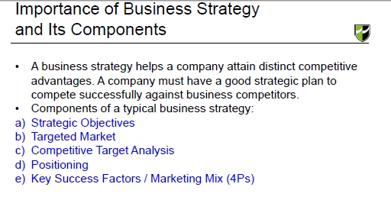

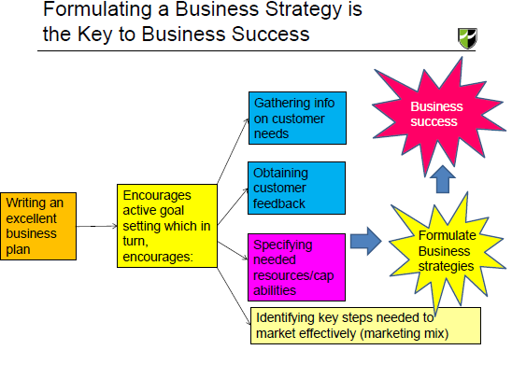

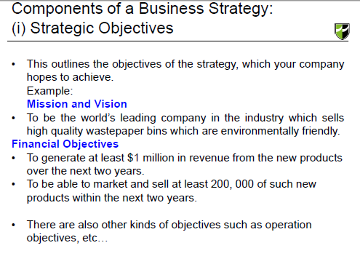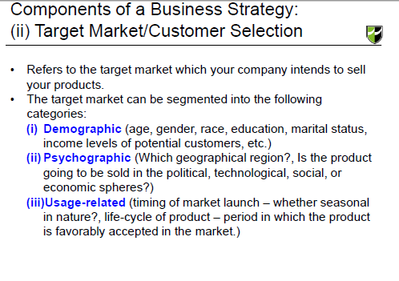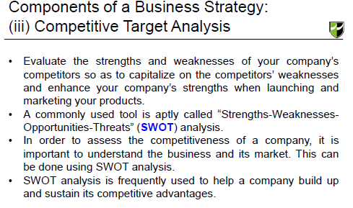

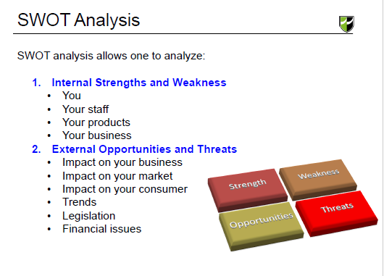

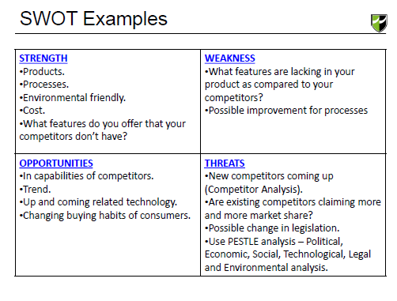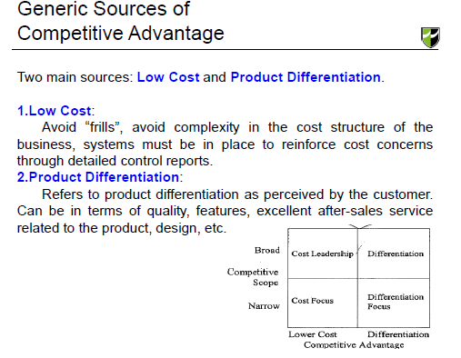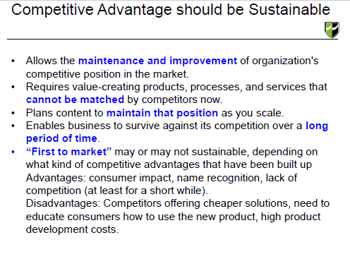

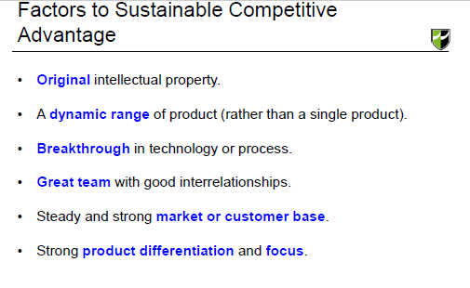

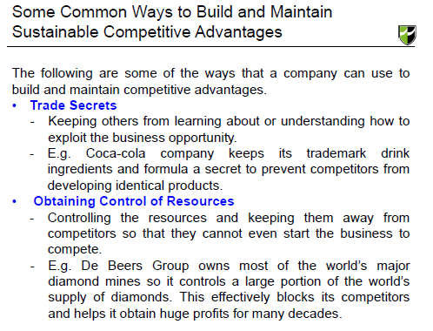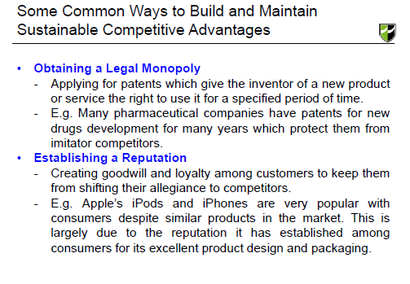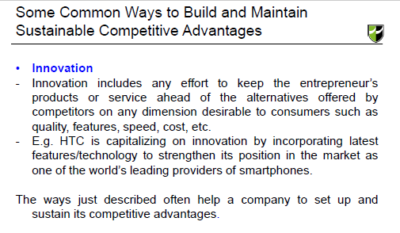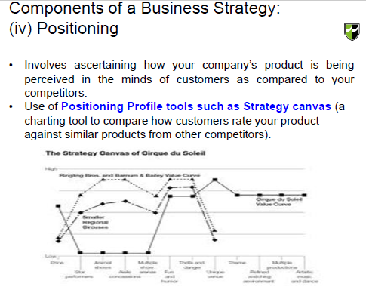

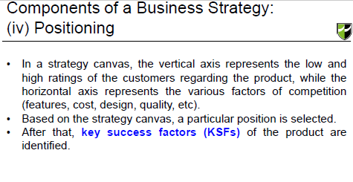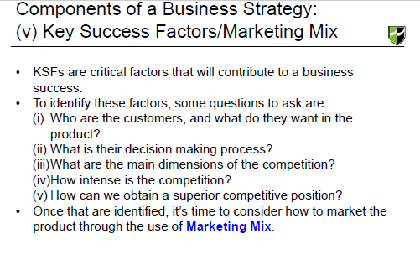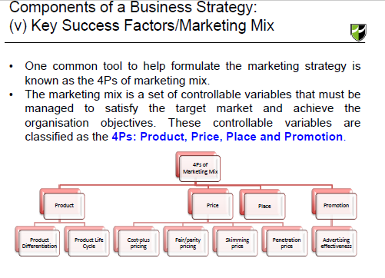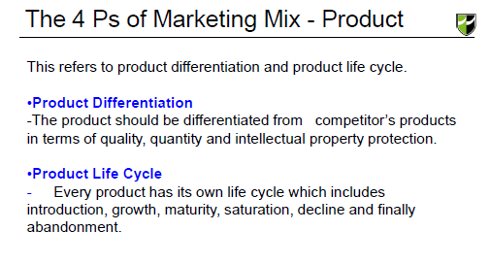

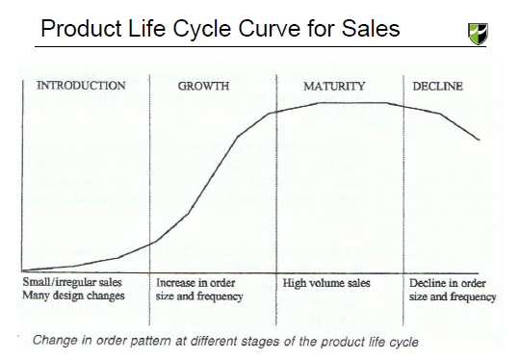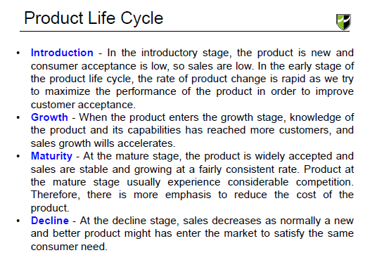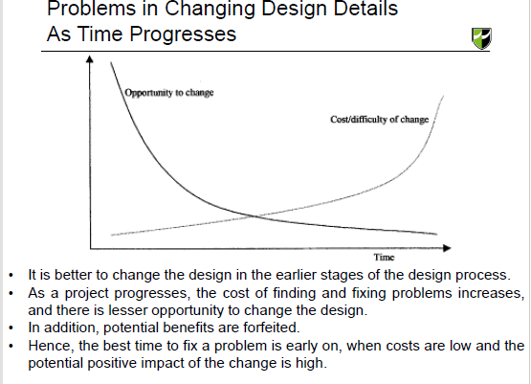

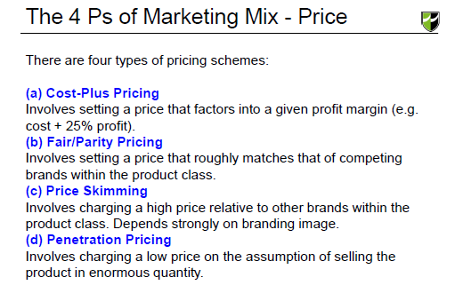

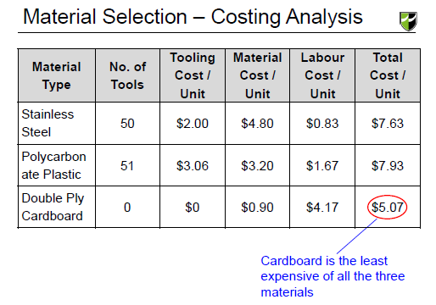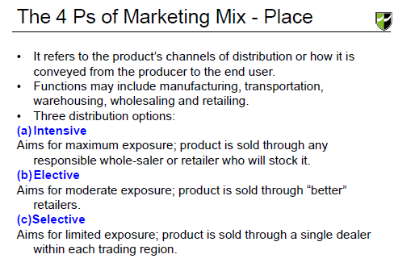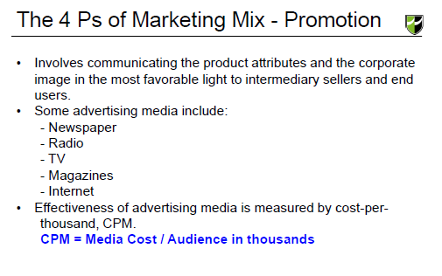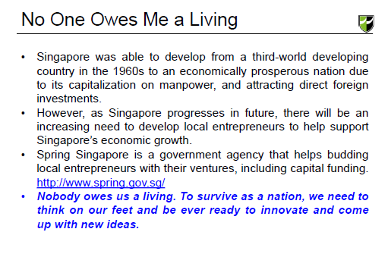

**Business Plan**

Executive Summary

Within the overall outline of the business plan, the executive summary will follow the title page. The summary should tell the reader what you want. This is very important. All too often, what the business owner desires is buried on page eight. Clearly state what you're asking for in the summary.

Business Description

The business description usually begins with a short description of the industry. When describing the industry, discuss the present outlook as well as future possibilities. You should also provide information on all the various markets within the industry, including any new products or developments that will benefit or adversely affect your business.

Market Strategies

Market strategies are the result of a meticulous market analysis. A market analysis forces the entrepreneur to become familiar with all aspects of the market so that the target market can be defined and the company can be positioned in order to garner its share of sales.

Competitive Analysis

The purpose of the competitive analysis is to determine the strengths and weaknesses of the competitors within your market, strategies that will provide you with a distinct advantage, the barriers that can be developed in order to prevent competition from entering your market, and any weaknesses that can be exploited within the product development cycle.

Design & Development Plan

The purpose of the design and development plan section is to provide investors with a description of the product's design, chart its development within the context of production, marketing and the company itself, and create a development budget that will enable the company to reach its goals.

Operations & Management Plan

The operations and management plan is designed to describe just how the business functions on a continuing basis. The operations plan will highlight the logistics of the organization such as the various responsibilities of the management team, the tasks assigned to each division within the company, and capital and expense requirements related to the operations of the business.

Financial Factors

Financial data is always at the back of the business plan, but that doesn't mean it's any less important than up-front material such as the business concept and the management team.

Business strategy

A business strategy is the means by which it sets out to achieve its desired ends (objectives). It can simply be described as a long-term business planning. Typically a business strategy will cover a period of about 3-5 years (sometimes even longer).

A business strategy is concerned with major resource issues e.g. raising the finance to build a new factory or plant. Strategies are also concerned with deciding on what products to allocate major resources to.Strategies are concerned with the scope of a business' activities i.e. what and where they produce.

Two main categories of strategies can be identified:

1. Generic (general) strategies, and

2. Competitive strategies.

The main types of generic strategies that organisations can pursue are:

1. Growth i.e. the expansion of the company to purchase new assets, including new businesses, and to develop new products. The Inland Revenue has expanded from being just a tax collector, to other functions such as collecting student loan repayments and paying tax credits.

2. Internationalisation/globalisation i.e. moving operations into more and more countries. For example, companies like Gillette, Coca-Cola, Kellogg's, and Cadbury Schweppes are major multinationals with operations across the globe.

3. Retrenchment involves cutting back to focus on your best lines. The Americans refer to this as 'sticking to the knitting' - i.e. concentrating on what you do best.

Competitive advantage

Competitive strategies are also important. Competitive strategies are concerned with doing things better than rivals. To be competitive a firm shouldn't just copy the ideas of rivals. They should seek to out compete rivals. There are two main ways of being competitive.

1. By selling goods at lower prices than rivals. This is possible when a firm is the market leader and benefits from economies of scale.

2. By differentiating your product from those of rivals - which enables you to charge a higher price if desired.

Economies of scale - The advantages that large firms have from producing large volumes of output enabling them to spread their costs over more units of output.

Differentiation - Making a product different from rival offerings e.g. through packaging and labelling, customer care, additional extra features, etc.

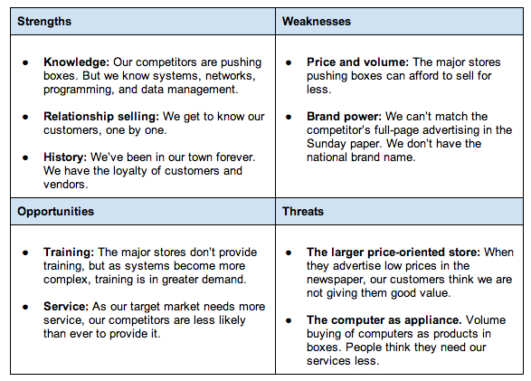

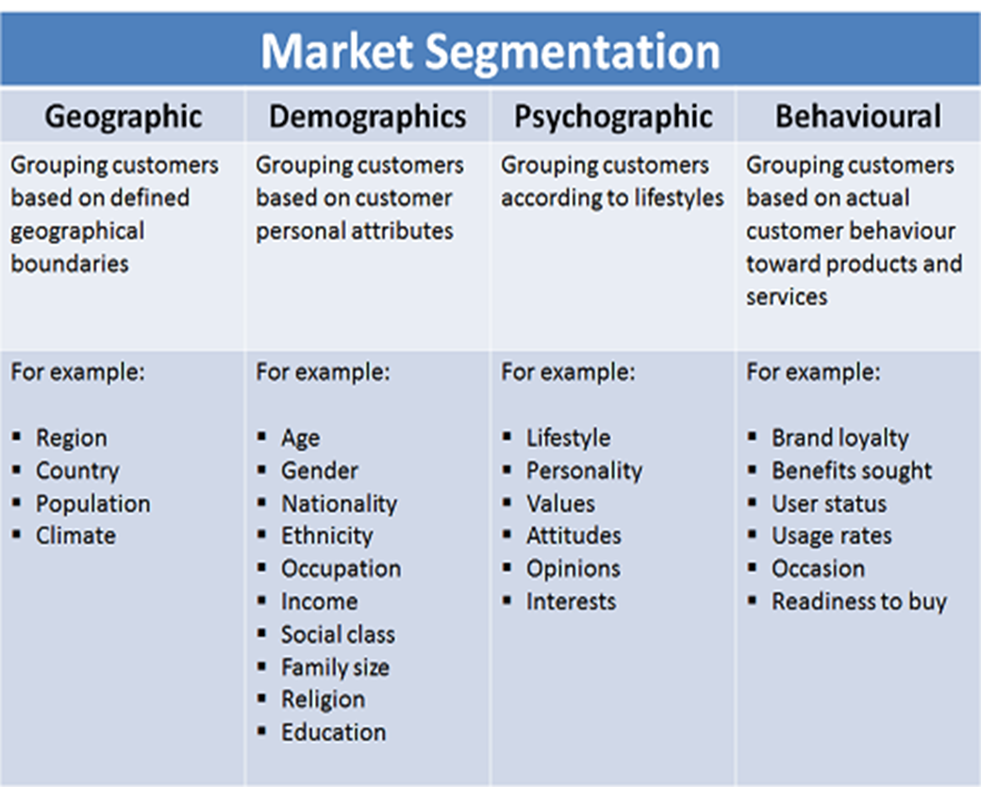

SMART Objectives

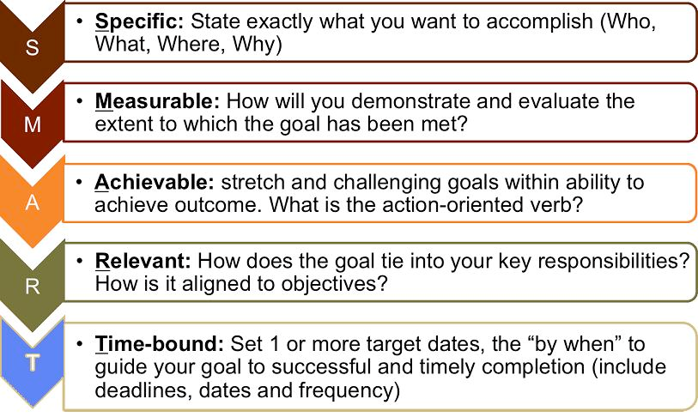

**What is SMART goal setting?**

SMART goal setting brings structure and trackability into your goals and objectives. In stead of vague resolutions, SMART goal setting creates verifiable trajectories towards a certain objective, with clear milestones and an estimation of the goal's attainabililty. Every goal or objective, from intermediary step to overarching objective, can be made S.M.A.R.T. and as such, brought closer to reality.

In corporate life, SMART goal setting is one of the most effective and yet least used tools for achieving goals. Once you've charted to outlines of your project, it's time to set specifice intermediary goals. With the SMART checklist, you can evaluate your objectives. SMART goal setting also creates transparency throughout the company. It clarifies the way goals came into existence, and the criteria their realisation will conform to.

**What does S.M.A.R.T. goal setting stand for?**

Why not think of a small goal you want to set right now, personal or professional. To make your goal S.M.A.R.T., it needs to conform to the following criteria: Specific, Measurable, Attainable, Relevant and Timely.

**S.M.A.R.T. goal setting: Specific**

What exactly do you want to achieve? The more specific your description, the bigger the chance you'll get exactly that. S.M.A.R.T. goal setting clarifies the difference between 'I want to be a millionaire' and 'I want to make €50.000 a month for the next ten years by creating a new software product'.

Questions you may ask yourself when setting your goals and objectives are:

* What exactly do I want to achieve?
* Where?
* How?
* When?
* With whom?
* What are the conditions and limitations?
* Why exactly do I want to reach this goal? What are possible alternative ways of achieving the same?

**S.M.A.R.T. goal setting: Measurable**

Measurable goals mean that you identify exactly what it is you will see, hear and feel when you reach your goal. It means breaking your goal down into measurable elements. You'll need concrete evidence. Being happier is not evidence; not smoking anymore because you adhere to a healthy lifestyle where you eat vegetables twice a day and fat only once a week, is.

Measurable goals can go a long way in refining what exactly it is that you want, too. Defining the physical manifestations of your goal or objective makes it clearer, and easier to reach.

**S.M.A.R.T. goal setting: Attainable**

Is your goal attainable? That means investigating whether the goal really is acceptable to you. You weigh the effort, time and other costs your goal will take against the profits and the other obligations and priorities you have in life.

If you don't have the time, money or talent to reach a certain goal you'll certainly fail and be miserable. That doesn't mean that you can't take something that seems impossible and make it happen by planning smartly and going for it!

There's nothing wrong with shooting for the stars; if you aim to make your department twice as efficient this year as it was last year with no extra labour involved, how bad is it when you only reach 1,8 times? Not too bad...

**S.M.A.R.T. goal setting: Relevant**

Is reaching your goal relevant to you? Do you want to run a multinational, be famous, have three children and a busy job? You decide for yourself whether you have the personality for it, or your team has the bandwidth.

If you're lacking certain skills, you can plan trainings. If you lack certain resources, you can look for ways of getting them.

The main questions, why do you want to reach this goal? What is the objective behind the goal, and will this goal really achieve that?

You could think that having a bigger team will make it perform better, but will it really?

**S.M.A.R.T. goal setting: Time Based**

Time is money! Make a tentative plan of everything you do. Everybody knows that deadlines are what makes most people switch to action. So install deadlines, for yourself and your team, and go after them. Keep the timeline realistic and flexible, that way you can keep morale high. Being too stringent on the timely aspect of your goal setting can have the perverse effect of making the learning path of achieving your goals and objectives into a hellish race against time – which is most likely not how you want to achieve anything.

Examples:

Broad Goal: I want to start a business.

1. Specific: I will sell handmade cards through Etsy.com.
2. Measurable: I will be ready to take my first Etsy order within four weeks, and I will aim to sell a minimum of five cards per week.
3. Attainable: I will get set up on Etsy first. Then, I will build an inventory of 30 handmade cards to sell. Finally, I will promote my business and build customer relationships through word of mouth, referrals and local networking.
4. Relevant: Selling handmade cards will allow me to benefit financially from my favorite hobby.
5. Time-Based: My Etsy store will be up and running within four weeks, and I will have an inventory of 30 cards to sell within six weeks.

Broad Goal: I want to grow my business.

* Specific: I will acquire three new clients for my consulting business.
* Measurable: I will measure my progress by how many new clients I bring on, while maintaining my current client base.
* Attainable: I will ask current clients for referrals, launch a social media marketing campaign and network with local businesses.
* Relevant: Adding additional clients to my business will allow me to grow my business and increase my revenue.
* Time-Based: I will have three new clients within two months.

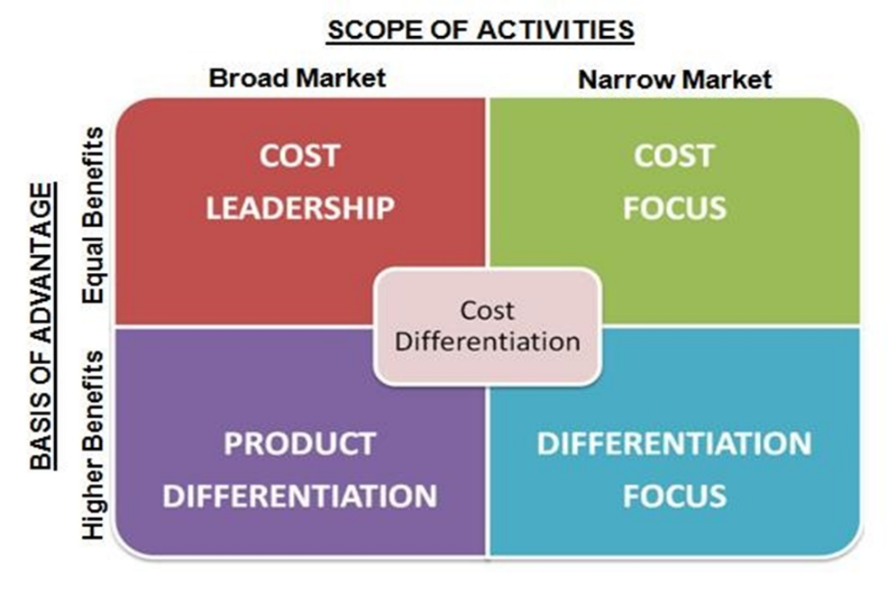

The Cost Leadership Strategy

1. Increasing profits by reducing costs, while charging industry-average prices.
2. Increasing market share through charging lower prices, while still making a reasonable profit on each sale because you've reduced costs.

Tip: Remember that Cost Leadership is about minimizing the cost to the organization of delivering products and services. The cost or price paid by the customer is a separate issue!

The Cost Leadership strategy is exactly that – it involves being the leader in terms of cost in your industry or market. Simply being amongst the lowest-cost producers is not good enough, as you leave yourself wide open to attack by other low-cost producers who may undercut your prices and therefore block your attempts to increase market share.

Cost Leadership Advantages:

1. Access to the capital needed to invest in technology that will bring costs down.
2. Very efficient logistics.
3. A low-cost base (labour, materials, facilities), and a way of sustainably cutting costs below those of other competitors.

Disadvantages

1. Cost leaders tend to keep their costs low by minimizing advertising, market research, and research and development, but this approach can prove to be expensive in the long run. A relative lack of market research can lead cost leaders to be less skilled than other firms at detecting important environmental changes.
2. Downplaying research and development can slow cost leaders’ ability to respond to changes once they are detected. Lagging rivals in terms of detecting and reacting to external shifts can prove to be a deadly combination that leaves cost leaders out of touch with the market and out of answers.

The Differentiation Strategy

Differentiation involves making your products or services different from and more attractive than those of your competitors. How you do this depends on the exact nature of your industry and of the products and services themselves, but will involve features, functionality, durability, support, and brand image that customers value.

To make a success of a Differentiation strategy, organizations need:

1. Good research, development and innovation.
2. The ability to deliver high-quality products or services.
3. Effective sales and marketing, so that the market understands the benefits offered by the differentiated offerings.

Large organizations pursuing a differentiation strategy need to stay agile with their new product development processes. Otherwise, they risk attack on several fronts by competitors pursuing Focus Differentiation strategies in different market segments.

Advantages:

1. Creates Value

When a company uses a differentiation strategy that focuses on the cost value of the product versus other similar products on the market, it creates a perceived value among consumers and potential customers. A strategy that focuses on value highlights the cost savings or durability of a product in comparison to other products.

1. Brand Loyalty

A successful product differentiation strategy creates brand loyalty among customers. The same strategy that gains market share through perceived quality or cost savings may create loyalty from consumers. The company must continue to deliver quality or value to consumers to maintain customer loyalty. In a competitive market, when a product doesn't maintain quality, customers may turn to a competitor.

Disadvantages:

1. Expensive

Customer needs keep on changing with time, and companies can only ignore this at their own peril. Companies that keep reinventing their products attract loyalty from customers, but product differentiation requires a lot of resources for carrying out a market research to know the customer needs, product development, launch, advertisement and monitoring.

1. Hinders Market Entry

It’s usually difficult for new firms to enter an existing market due to several barriers. One such hurdle is product differentiation, which gives established brands an upper hand. Most customers remain loyal to the well-known brands in the market and rarely try out products made by new entrants. Usually, if newcomers use price differentiation to entice customers, well-established brands launch a similar low-priced item to protect their market share.

The Focus Strategy

Companies that use Focus strategies concentrate on particular niche markets and, by understanding the dynamics of that market and the unique needs of customers within it, develop uniquely low-cost or well-specified products for the market. Because they serve customers in their market uniquely well, they tend to build strong brand loyalty amongst their customers. This makes their particular market segment less attractive to competitors.

As with broad market strategies, it is still essential to decide whether you will pursue Cost Leadership or Differentiation once you have selected a Focus strategy as your main approach: Focus is not normally enough on its own.

But whether you use Cost Focus or Differentiation Focus, the key to making a success of a generic Focus strategy is to ensure that you are adding something extra because of serving only that market niche. It's simply not enough to focus on only one market segment because your organization is too small to serve a broader market (if you do, you risk competing against better-resourced broad market companies' offerings).

The "something extra" that you add can contribute to reducing costs (perhaps through your knowledge of specialist suppliers) or to increasing differentiation (though your deep understanding of customers' needs).

Tip: Generic strategies apply to not-for-profit organizations too.

A not-for-profit can use a Cost Leadership strategy to minimize the cost of getting donations and achieving more for its income, while one pursuing a Differentiation strategy will be committed to the very best outcomes, even if the volume of work it does as a result is smaller.

Local charities are great examples of organizations using Focus strategies to get donations and contribute to their communities.

Choosing the Right Generic Strategy

Your choice of which generic strategy to pursue underpins every other strategic decision you make, so it's worth spending time to get it right.

But you do need to make a decision: Porter specifically warns against trying to "hedge your bets" by following more than one strategy. One of the most important reasons why this is wise advice is that the things you need to do to make each type of strategy work appeal to different types of people. Cost Leadership requires a very detailed internal focus on processes. Differentiation, on the other hand, demands an outward-facing, highly creative approach.

So, when you come to choose which of the three generic strategies is for you, it's vital that you take your organization's competencies and strengths into account.

Use the following steps to help you choose.

Step 1:

For each generic strategy, carry out a SWOT Analysis Add to My Personal Learning Plan of your strengths and weaknesses, and the opportunities and threats you would face, if you adopted that strategy.

Having done this, it may be clear that your organization is unlikely to be able to make a success of some of the generic strategies.

Step 2:

Use Five Forces Analysis. Add to My Personal Learning Plan to understand the nature of the industry you are in.

Step 3:

Compare the SWOT Analyses of the viable strategic options with the results of your Five Forces analysis. For each strategic option, ask yourself how you could use that strategy to:

* Reduce or manage supplier power.
* Reduce or manage buyer/customer power.
* Come out on top of the competitive rivalry.
* Reduce or eliminate the threat of substitution.
* Reduce or eliminate the threat of new entry.
* Select the generic strategy that gives you the strongest set of options.

Tip: Porter's Generic Strategies offer a great starting point for strategic decision-making.

Once you've made your basic choice, though, there are still many strategic options available. Bowman's Strategy Clock Add to My Personal Learning Plan helps you think at the next level of details, because it splits Porter's options into eight sub-strategies. You can also use USP Analysis Add to My Personal Learning Plan and Core Competence Analysis Add to My Personal Learning Plan to identify the areas you should focus on to stand out in your marketplace.

Key Points

According to Porter's Generic Strategies model, there are three basic strategic options available to organizations for gaining competitive advantage. These are: Cost Leadership, Differentiation and Focus.

Organizations that achieve Cost Leadership can benefit either by gaining market share through lowering prices (whilst maintaining profitability) or by maintaining average prices and therefore increasing profits. All of this is achieved by reducing costs to a level below those of the organization's competitors.

Companies that pursue a Differentiation strategy win market share by offering unique features that are valued by their customers. Focus strategies involve achieving Cost Leadership or Differentiation within niche markets in ways that are not available to more broadly-focused players.

Examples:

1. Cost Leadership – McDonalds, Ikea
2. Differentiation – Apple, NIKE

**Advertising Media**

For a small business, every dollar is precious. Small businesses do not advertise for the sake of advertising. Instead, they want to get the most return for their investment. Your advertising campaign should translate to greater sales, more profits and healthier bottom line.

While there are a number of venues where you can promote your business, you need to ask three important questions:

1. Where are my target buyers?
2. What is the best medium to reach them?
3. Can I afford to launch an effective campaign using this medium?

An important step to developing your sales and marketing plan is to select the right media to send out your message. There are no hard-and-fast rules as to which media is better. The right media for one business may be wrong for another.

Below are the relative advantages and disadvantages of the various advertising medium used by small businesses:



Pay Per Click Advertising (Search Engines)

As the Web becomes a must-use daily medium today, pay per click (PPC) advertising has grown by leaps and bounds. PPC advertisement is a form of advertising where ads are run and shown in search engines (including their partner sites). PPC ads allow advertisers to pay for visitors on mostly cost per click basis, though some options for cost per impressions are available as well.

Advantages of Pay Per Click Advertising

* Pay only for results (clicks)
* Ability to select where your ads will be shown, giving a better chance to reach target audiences
* Can generate immediate visibility, as ads go live immediately
* Ads can be easily modified, adjusted even deleted instantaneously depending on the results
* Allows for quick, easy tracking of the effectiveness of the campaign allowing you to better analyze the return on your investments (ROI)

Disadvantages of Pay Per Click Advertising

* Broad match, the default option where the ad is shown and automatically matched against a broad array of related queries, can result in ads that are irrelevant to the intended search.
* Bid price inflation as more advertisers compete for the keywords and bid the prices up for the terms
* Bidding war could also result where competitors can bid a higher amount than your bid, lowering the position of the ad and decreasing its visibility
* Click through fraud where users maliciously click on the adverts, from disgruntled competitors to website owners who earns from ads shown on their pages
* Requires constant monitoring; otherwise, outsource to a PPC management company which in turn will increase the cost of your advertising campaign

Social Media Advertising

As Web has evolved into a medium that fosters social connection, social media has experienced an astounding growth in the last few years. Social media consists of both social networking sites and social bookmarking sites and includes blogs, video sharing sites such as Youtube, microblogging platform Twitter, Facebook, LinkedIn, Stumbleupon and the like.

Advantages of Social Media Advertising

* Social media sites are great for building customer relationship and offers an incredible reach and the opportunity to connect with customers in an entirely new way
* Offers a wide reach, with its potential for viral marketing
* Traffic generated can be extremely targeted
* Social media tools are relatively inexpensive

Disadvantages of Social Media Advertising

* Targeting is so low because of the diversity and breadth of audiences, resulting in low ROI as visitors do not convert
* Visitors mainly go to social media sites to socialize, and are not interested in advertising
* Traffic is typically in the learning stage of the buying process; hence it is more important to inform and teach than sell outright
* Social media can be a hard branding tool for small businesses, and it is not easy to build awareness, create appeal and generate traffic

Banner Advertising

Banner advertising is one of the dominant forms of advertising online. It entails the display of a graphical advertising unit, with the typical size the 468×60 banners. However, it also includes buttons, leaderboards, popups, popunders, interstitials, and flash banners. Banner advertising can be run for cost per impression, cost per click or even cost per action.

Advantages of Banner Advertising

* Prices (CPM and CPC rates) have gone down through the years
* With good placement and design, banner ads can deliver above-industry average click through rates
* Banner ads are good branding tools
* Easy to track with the available ad serving tools and tracking tools
* Banner ads can bring in targeted traffic interested in your offerings

Disadvantages of Banner Advertising

* Some types of banner advertising — e.g. flashing banners, popups, popunders, interstitials — are often seen as annoying and highly intrusive
* Growing usage of popup and ad blockers that prevents users from seeing the ads
* Click through rates have significantly declined, due to poor banner design to accumulated bad experiences of web users
* Oversaturation of banner ads leads to ad blindness

Direct Mail

Direct mail, often called direct marketing or direct response marketing, is a marketing technique in which the seller sends marketing messages directly to the buyer. Direct mail include catalogs or other product literature with ordering opportunities; sales letters; and sales letters with brochures.

Advantages of Direct Mail Advertising

* Your advertising message is targeted to those most likely to buy your product or service.
* Marketing message can be personalized, thus helping increase positive response.
* Your message can be as long as is necessary to fully tell your story.
* Effectiveness of response to the campaign can be easily measured.
* You have total control over the presentation of your advertising message.
* Your ad campaign is hidden from your competitors until it’s too late for them to react
* Active involvement – the act of opening the mail and reading it — can be elicited from the target market.

Disadvantages of Direct Mail

* Some people do not like receiving offers in their mail, and throw them immediately without even opening the mail.
* Resources need to be allocated in the maintenance of lists, as the success of this kind of promotional campaign depends on the quality of your mailing list.
* Long lead times are required for creative printing and mailing
* Producing direct mail materials entail the expense of using various professionals – copywriter, artists, photographers, printers, etc.
* Can be expensive, depending on your target market, quality of your list and size of the campaign.

Newspapers

Newspapers are one of the traditional mediums used by businesses, both big and small alike, to advertise their businesses.

Advantages of Newspaper Advertising

* Allows you to reach a huge number of people in a given geographic area
* You have the flexibility in deciding the ad size and placement within the newspaper
* Your ad can be as large as necessary to communicate as much of a story as you care to tell
* Exposure to your ad is not limited; readers can go back to your message again and again if so desired.
* Free help in creating and producing ad copy is usually available
* Quick turn-around helps your ad reflect the changing market conditions. The ad you decide to run today can be in your customers’ hands in one to two days.

Disadvantages of Newspaper Advertising

* Ad space can be expensive
* Your ad has to compete against the clutter of other advertisers, including the giants ads run by supermarkets and department stores as well as the ads of your competitors
* Poor photo reproduction limits creativity
* Newspapers are a price-oriented medium; most ads are for sales
* Expect your ad to have a short shelf life, as newspapers are usually read once and then discarded.
* You may be paying to send your message to a lot of people who will probably never be in the market to buy from you.
* Newspapers are a highly visible medium, so your competitors can quickly react to your prices
* With the increasing popularity of the Internet, newspapers face declining readership and market penetration. A growing number of readers now skip the print version of the newspaper (and hence the print ads) and instead read the online version of the publication.

Magazines

Magazines are a more focused, albeit more expensive, alternative to newspaper advertising. This medium allows you to reach highly targeted audiences.

Advantages of Magazine Advertising

* Allows for better targeting of audience, as you can choose magazine publications that cater to your specific audience or whose editorial content specializes in topics of interest to your audience.
* High reader involvement means that more attention will be paid to your advertisement
* Better quality paper permits better color reproduction and full-color ads
* The smaller page (generally 8 ½ by 11 inches) permits even small ads to stand out

Disadvantages of Magazine Advertising

* Long lead times mean that you have to make plans weeks or months in advance
* The slower lead time heightens the risk of your ad getting overtaken by events
* There is limited flexibility in terms of ad placement and format.
* Space and ad layout costs are higher

Yellow Pages

There are several forms of Yellow Pages that you can use to promote and advertise your business. The Web version of Yellow Pages (and its many competitors online) have been growing by leaps and bounds in recent years, with many foregoing the traditional Yellow Pages supplied by phone companies. But you can also check out specialized directories targeted to specific markets (e.g. Hispanic Yellow Pages, Blacks, etc.); interactive or consumer search databases; Audiotex or talking yellow pages; Internet directories containing national, local and regional listings; and other services classified as Yellow Pages.

Advantages of Yellow Page Advertising

* Wide availability, as mostly everyone have Yellow Pages
* Non-intrusive
* Action-oriented, as the audience is actually looking for the ads
* Ads are reasonably inexpensive
* Responses are easily tracked and measured
* Frequency

Disadvantages of Yellow Page Advertising

* The Internet has led to the decline in the usage of the Yellow Pages, as users find the Web to be an easier, faster and more comprehensive
* Pages can look cluttered, and your ad can easily get lost in the clutter
* Your ad is placed together with all your competitors
* Limited creativity in the ads, given the need to follow a pre-determined format
* Ads slow to reflect market changes
* Radio

Radio

Advantages of Radio Advertising

* Radio is a universal medium enjoyed by people at one time or another during the day, at home, at work, and even in the car.
* The vast array of radio program formats offers to efficiently target your advertising dollars to narrowly defined segments of consumers most likely to respond to your offer.
* Gives your business personality through the creation of campaigns using sounds and voices
* Free creative help is often available
* Rates can generally be negotiated
* During the past ten years, radio rates have seen less inflation than those for other media

Disadvantages of Radio Advertising

* Because radio listeners are spread over many stations, you may have to advertise simultaneously on several stations to reach your target audience
* Listeners cannot go back to your ads to go over important points
* Ads are an interruption in the entertainment. Because of this, a radio ad may require multiple exposure to break through the listener’s “tune-out” factor and ensure message retention
* Radio is a background medium. Most listeners are doing something else while listening, which means that your ad has to work hard to get their attention

Television

Advantages of Television Advertising

* Television permits you to reach large numbers of people on a national or regional level in a short period of time
* Independent stations and cable offer new opportunities to pinpoint local audiences
* Television being an image-building and visual medium, it offers the ability to convey your message with sight, sound and motion

Disadvantages of Television Advertising

* Message is temporary, and may require multiple exposure for the ad to rise above the clutter
* Ads on network affiliates are concentrated in local news broadcasts and station breaks
* Preferred ad times are often sold out far in advance
* Limited length of exposure, as most ads are only thirty seconds long or less, which limits the amount of information you can communicate
* Relatively expensive in terms of creative, production and airtime costs

Telemarketing

Telephone sales, or telemarketing, is an effective system for introducing a company to a prospect and setting up appointments

Advantages of Telemarketing

* Provides a venue where you can easily interact with the prospect, answering any questions or concerns they may have about your product or service.
* It’s easy to prospect and find the right person to talk to.
* It’s cost-effective compared to direct sales.
* Results are highly measurable.
* You can get a lot of information across if your script is properly structured.
* If outsourcing, set-up cost is minimal
* Increased efficiency since you can reach many more prospects by phone than you can with in-person sales calls.
* Great tool to improve relationship and maintain contact with existing customers, as well as to introduce new products to them
* Makes it easy to expand sales territory as the phone allows you to call local, national and even global prospects.

Disadvantages of Telemarketing

* An increasing number of people have become averse to telemarketing.
* More people are using technology to screen out unwanted callers, particularly telemarketers
* Government is implementing tougher measures to curb unscrupulous telemarketers
* Lots of businesses use telemarketing.
* If hiring an outside firm to do telemarketing, there is lesser control in the process given that the people doing the calls are not your employees
* May need to hire a professional to prepare a well-crafted and effective script
* It can be extremely expensive, particularly if the telemarketing is outsourced to an outside firm
* It is most appropriate for high-ticket retail items or professional services.

Specialty Advertising

This kind of advertising entails the use of imprinted, useful, or decorative products called advertising specialties, such as key chains, computer mouse, mugs, etc. These articles are distributed for free; recipients need not purchase or make a contribution to receive these items.

Advantages of Specialty Advertising:

* Flexibility of use
* High selectivity factor as these items can be distributed only to the target market.
* If done well, target audience may decide to keep the items, hence promoting long retention and constant exposure
* Availability of wide range of inexpensive items that can be purchased at a low price.
* They can create instant awareness.
* They can generate goodwill in receiver
* The items can be used to supplement other promotional efforts and media (e.g. distributed during trade shows).

Disadvantages of Specialty Advertising

* Targeting your market is difficult.
* This can be an inappropriate medium for some businesses.
* It is difficult to find items that are appropriate for certain businesses
* Longer lead time in developing the message and promotional product
* Possibility of saturation in some items and audiences
* Wrong choice of product or poor creative may cheapen the image of advertiser

**Understanding the Marketing Mix Concept – 4Ps**

Marketing is simplistically defined as ‘putting the right product in the right place, at the right price, at the right time.’ Though this sounds like an easy enough proposition, a lot of hard work and research needs to go into setting this simple definition up. And if even one element is off the mark, a promising product or service can fail completely and end up costing the company substantially.

The use of a marketing mix is an excellent way to help ensure that ‘putting the right product in the right place,…’ will happen. The marketing mix is a crucial tool to help understand what the product or service can offer and how to plan for a successful product offering. The marketing mix is most commonly executed through the 4 P’s of marketing: Price, Product, Promotion, and Place.

THE FOUR P’S

Product

The product is either a tangible good or an intangible service that is seem to meet a specific customer need or demand. All products follow a logical product life cycle and it is vital for marketers to understand and plan for the various stages and their unique challenges. It is key to understand those problems that the product is attempting to solve. The benefits offered by the product and all its features need to be understood and the unique selling proposition of the product need to be studied. In addition, the potential buyers of the product need to be identified and understood.

Price

Price covers the actual amount the end user is expected to pay for a product. How a product is priced will directly affect how it sells. This is linked to what the perceived value of the product is to the customer rather than an objective costing of the product on offer. If a product is priced higher or lower than its perceived value, then it will not sell. This is why it is imperative to understand how a customer sees what you are selling. If there is a positive customer value, than a product may be successfully priced higher than its objective monetary value. Conversely, if a product has little value in the eyes of the consumer, then it may need to be underpriced to sell. Price may also be affected by distribution plans, value chain costs and markups and how competitors price a rival product.

Promotion

The marketing communication strategies and techniques all fall under the promotion heading. These may include advertising, sales promotions, special offers and public relations. Whatever the channel used, it is necessary for it to be suitable for the product, the price and the end user it is being marketed to. It is important to differentiate between marketing and promotion. Promotion is just the communication aspect of the entire marketing function.

Place

Place or placement has to do with how the product will be provided to the customer. Distribution is a key element of placement. The placement strategy will help assess what channel is the most suited to a product. How a product is accessed by the end user also needs to compliment the rest of the product strategy.

This question will explain on how to calculate the cost to produce a product. Assuming that the product can be made using three different materials: Stainless Steel, Plastic, and Cardboard. Based on a market survey, the average life cycle of the product is 4 years. Volume projection of the product is at an average of 500,000 per year supplying to Singapore.

Tooling estimation taken from previous products are such:

* 1. Stainless steel product design requires a set of five stamping and forming tools. Each tooling costs approximately $20,000 with a life of 50,000 piece part (i.e. tool needs to be replaced after servicing every 50,000 parts). Metal sheet and rod needed for the product is $4.80. Labour is at 10mins per product for assembly.
  2. Plastic product design requires a set of three plastic injection moulds. Each mould costs approximately $30,000 with a life of 30,000 piece part. Plastic resin needed for the product is $3.20. Labour is at 20mins per product for assembly.
  3. Cardboard product design requires no tooling. Double ply corrugated paper needed for the product is $0.90. Average fabrication and assembly duration is 50mins per product.

Calculate the cost to produce one product,with labour cost at $5.00 per hour.

An example for the calculation of the total cost per unit for stainless steel is as shown below in Table 5. Fill up the information for the remaining materials and rank the material options in view of per unit manufacturing cost of the product. (You may wish to use an Excel Spreadsheet for the calculation)

|  |  |  |  |  |  |
| --- | --- | --- | --- | --- | --- |
| **Material Type** | **No. of Tools** | **Tooling Cost / Unit** | **Material Cost / Unit** | **Labour Cost / Unit** | **Total Cost / Unit** |
| Stainless  Steel | $\frac{Needed to be produced}{number for life of parts}$**× sets required**  **= $\frac{500000}{50000}$ ×5**  **=50** | $\frac{Tool Costs}{Needed to be produced}$**× No. of Tools**  **= $\frac{20000}{500000}$ × 20**  **=$2.00** | **$4.80(Given)** | **$5/6**  **=$0.83** | **Tooling Cost / Unit+ Material Cost / Unit+ Labour Cost / Unit$**  **= $2.00 + $4.80 + $0.83**  **= 7.63** |
| Polycarbonate Plastic | **$50** | **$3** | **$3.20** | **$1.67** | **$7.87** |
| Double Ply Cardboard | **0** | **0** | **$0.90** | **$4.17** | **$5.07** |

**Simple Machines**

Simple machines are basic mechanical devices that make work easier for us by allowing us to push or pull over increased distances with an applied force.

Mechanical Advantage

Mechanical advantage (MA) is the how much a machine multiplies the effort force put into it. The mechanical advantage can be calculated for the following simple machines by using the following formulas:

Lever: MA = length of effort arm / length of resistance arm.

Pulley: All pulleys have a fixed MA depending on the type. A pulley with one rope (single fixed pulley) has an MA = 1. A pulley with two ropes (single moveable pulley) has a MA = 2. A pulley with 6 ropes (block and tackle) has an MA = 4.

Wheel and Axle: MA = radius of wheel / radius of axle

Inclined Plane: MA = length of slope / height of slope

Most generally, the mechanical advantage is calculated thus:

MA = (the distance over which one must apply the force)/(the distance one wishes to move an object)

This requires an ideal simple machine, meaning that there are no losses due to friction or elasticity. This formula can be derived from the idea of conservation of energy.

“Mechanical advantage is a measure of the force amplification achieved by using a tool, mechanical device or machine system. Ideally, the device preserves the input power and simply trades off forces against movement to obtain a desired amplification in the output force. The model for this is the law of the lever.” – From Wikipedia

Types of Simple Machines:

1. The Lever

The lever is a long tool such as a pole or a rod put under an object to lift it. The lever is more efficient when combined with a fulcrum. The fulcrum is another object, perhaps a rock, used to brace under the long tool. This gives the long pole something to push down against. The location of the fulcrum helps determine how well the lever will perform work. The closer the fulcrum is to the object being lifted, the easier the person can lift the object. The longer the lever, the higher the object can be lifted. Do the math — it's really all in the distance between the object, the fulcrum and the lever.

Examples: door handles, the claws of a hammer (for removing nails), crowbars, light switches, bottle openers and hinges

1. The Wheel & Axle

The wheel has always been considered a major invention in the history of mankind. But it really would not work as well as it does had it not been for the axle. An axle is a rod or pole centered in the wheel that allows the wheel to turn around it. The wheel then spins in a balanced circle to be used as transportation on a bike or to turn the hands of a clock. Gears are a form of the wheel and axle.

Examples: an electric fan, a motor, a revolving door, a merry go round, and any wheel

1. The Inclined Plane

The inclined plane is simply a ramp. One end is higher than the opposite end. This allows things to go from a low point to a higher point. Or vice versa. It takes the same amount of work, but less force, to move an object up a ramp than to move it vertically. Gravity makes it easier to move an object down a ramp than up that ramp.

Examples: skateboard parks, wheelchair ramps. a modified version of a ramp is also found in stairs, escalators, ladders, walking paths

1. The Wedge

Some people might see the wedge as just an inclined plane, although it is actually two inclined planes. However, the use of a wedge is actually different in nature. The wedge is used to separate an object apart. This is needed to cut, tear or break something in two. A wedge can also be used to keep things together or secure things from movement.

Examples: shovel, a knife, an axe, a pick axe, a saw, a needle, scissors, or an ice pick

1. Pulley

The pulley is actually a version of a wheel and axle that is combined with a rope, chain or other cord to allow moving something up and down or back and forth. The pulley can be combined with other pulleys to reduce the amount of work necessary to lift huge amounts of weight or to lower them down. It can also make moving something such as a flag up the pole convenient to do from the ground. It changes the direction of the force necessary to do the work. I pull down on the rope, but the flag goes up.

Examples: Pulleys are used in window blinds and drapery to move them up and down or back and forth. Pulleys are also used on ships to raise and lower sails, in industry to raise and lower heavy cargo, or on cranes for use in moving construction equipment. Elevators also use pulleys to move the car up and down from floor to floor.

1. The Screw

The screw is really a twisted inclined plane. It allows movement from a lower position to a higher position but at the same time it moves it in a circle. That makes it take up less horizontal space. A screw can also act to hold things together in some cases.

Examples: a jar lid, a drill, a bolt, a light bulb, faucets, bottle caps and ball point pens

Compound Machine

Simple machines can be combined to form compound machines. Many of our everyday tools and the objects we use are really compound machine. Scissors are a good example. The edge of the blades are wedges. But the blades are combined with a lever to make the two blades come together to cut.

A lawnmower combines wedges (the blades) with a wheel and axle that spins the blades in a circle. But there is even more. The engine probably works in combination of several simple machines and the handle that you use to push the lawnmower around the yard is a form of a lever. So even something complicated can be broken down into the simplest of machines.

The Lever

The lever is one of the most basic forms of a machine. They help us lift loads with lesser effort. Even though this looks simple there are many things going on to lift the object easily.

A lever can be described as a long rigid body with a fulcrum along its length.

Load: The object you’re lifting.

Fulcrum: Point at which the lever pivots.

Effort: The force applied to make the object move.

Levers are classified into three categories depending on the relative position of the load, fulcrum and force.

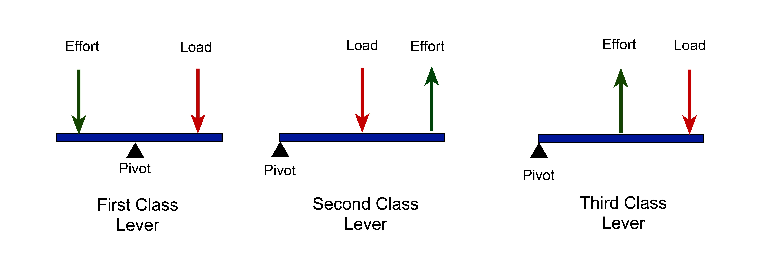The 1st Class Lever – where, the pivot is in between the effort and the load.

The 2nd Class Lever – where, the load is between the fulcrum and the effort.

The 3nd Class Lever – where, the effort is between the fulcrum and the load.

Examples for each category;

1st Class Lever - see-saws, crowbars, pliers, scissors

2nd Class Lever - doors, staplers, wheelbarrows, can openers

3rd Class Lever - broom, fishing rod

How does the lever work and what mechanical advantage can they give us? Is the mechanical advantage a constant value or can it be made to vary?

A lever is simply a plank or ridged beam that is free to rotate on a pivot. Levers affect the effort, or force, needed to do a certain amount of work, and are used to lift heavy objects.

The mechanical advantage is a constant and this is because the force applied (at end points of the lever) is proportional to the ratio of the length of the lever arm measured between the fulcrum and application point of the force applied at each end of the lever. Mathematically, this is expressed by M = Fd.

Mechanical Advantage Formula

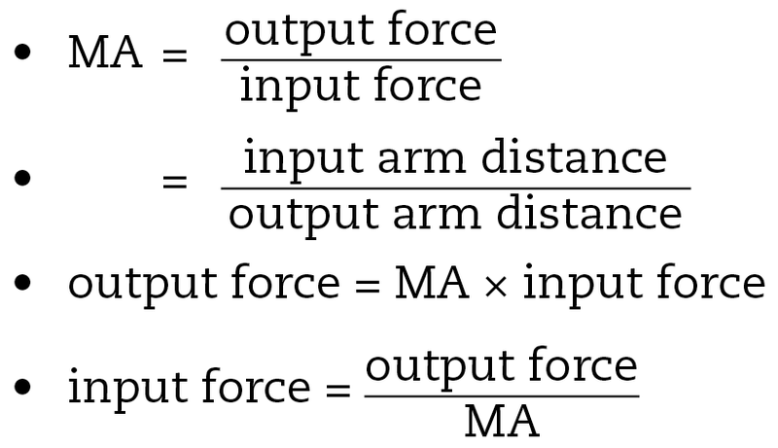

Output force= Load/Force Given

Input Force= Effort used

Input Distance= Distance between Effort and Pivot

Output Distance= Distance between load/force given and pivot